Library of Congress
How to Navigate the LOC.GOV Website

WARNING: This is a difficult site to navigate! Here are a few key helps to make it easier to find Primary Sources for your Library Class use.
Go to LOC.GOV
Click on TEACHERS (JUMPING OFF POINT!!) This will take you to the Teachers Page on the Library of Congress website.
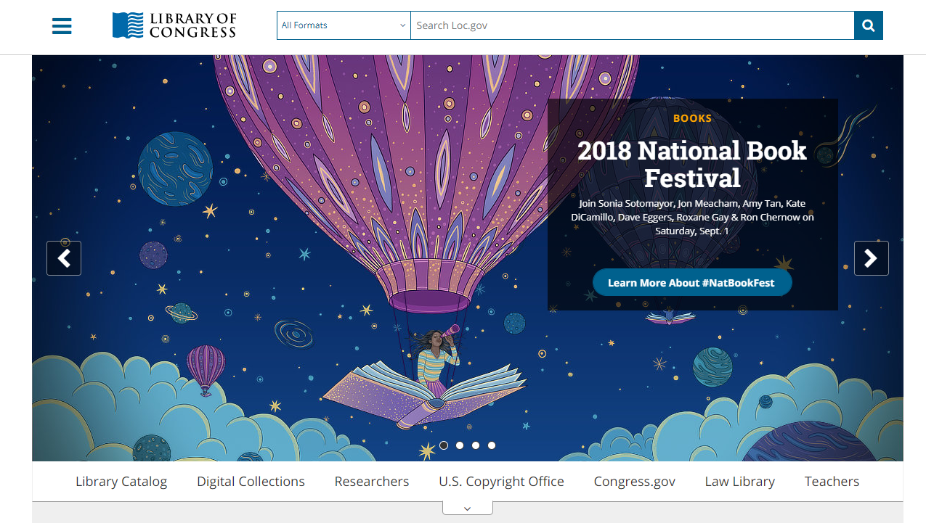
Once on the Teachers Page, you have several options on the LEFT SIDE BAR.
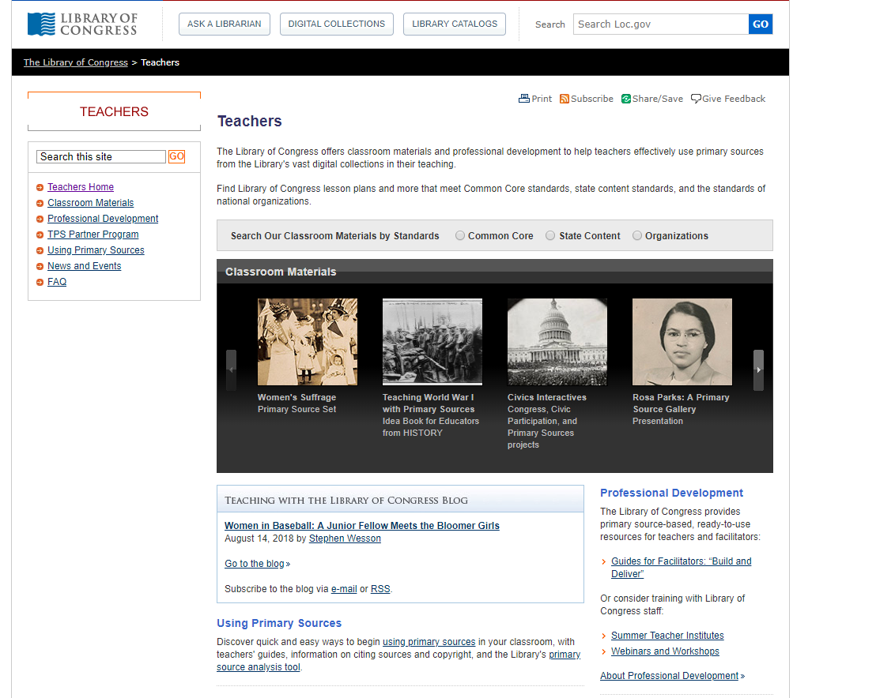

On the LEFT SIDEBAR of the Teachers Page, look for CLASSROOM MATERIALS. This option drills down to the MOST beneficial uses for the LOC.GOV website.
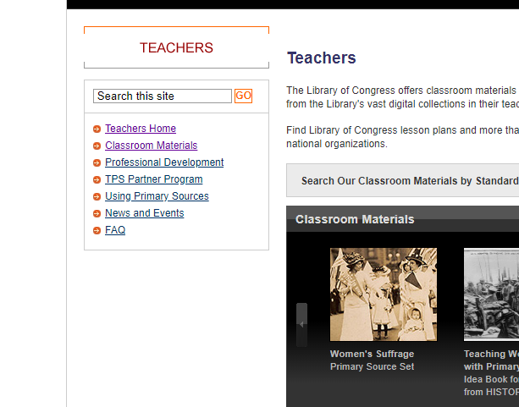

On the CLASSROOM MATERIALS page, you have the folloing options::
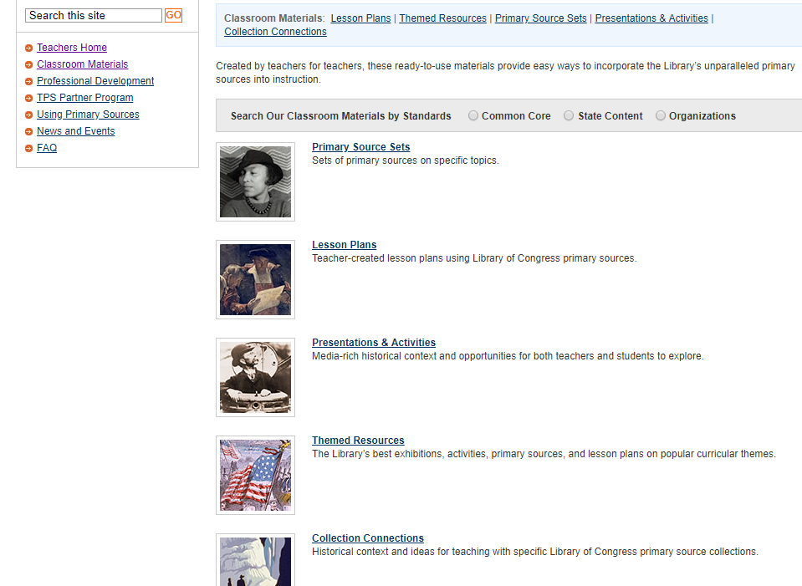
Primary Source Sets: This lists a variety of topics.
Some primary source sets have free ebooks
attached.

Lesson Plans: Teacher created lesson plans with
grade level options. Plans can be searched
by “ERA” or “ALPHABETICALLY.

Presentations and Activities: The presentations
and activities are arranged chronologically.
Many of the presentations take you to
another site on the LOC.GOV website.
The activities can be interactive with a
Resource guide to assist the teacher.

Themed Resources: Search primary sources by
theme (e.g. baseball, elections, holidays)

Collection Connection: Historical context and ideas
for teaching with specific Library of Congress primary source collections.

Again on the LEFT SIDEBAR, find USING PRIMARY SOURCES page. This page states the rationale for using primary sources, citing and copyright of primary sources helps are provided. This link also includes a Teacher’s Guide and the Analysis Tool.

BENEFICIAL INFORMATION TO ASSIST IN TEACHING PRIMARY SOURCES

At the TOP of the TEACHERS PAGE is a VERY IMPORTANT TAB: ASK A LIBRARIAN

Ask a Librarian is a form that you can fill out to receive assistance for use of the site or a primary source. It may take 24 hours for a reply.

LEFT SIDEBAR PROFESSIONAL DEVELOPMENT
You can access PD Activities and Videos, Webinars and Workshops. The Webinar includes 2015 and 2016 Online Conferences. There is a variety of sessions discussing resources and teaching strategies.

You can also apply for the Summer Teacher Institute on this page.

Another helpful location is DIGITAL COLLECTIONS found on the home page of loc.gov

DIGITAL COLLECTIONS is a location that has a variety of resources available. You can search by subject, part of (a collection) or original format. Some of the original formats include: maps, video recordings, sound recordings, etc.

CHRONICALING AMERICA: HISTORIC AMERICAN NEWSPAPERS
Chronicling America provides access to historic newspapers and selected digitized newspaper pages. “The National Endowment for the Humanities (NEH) and the Library of Congress (LC), is a long-term effort to develop an Internet-based, searchable database of U.S. newspapers with descriptive information and select digitization of historic pages.”

