How to Upload Custom Sounds to Your Destiny Program
Click on the “Back Office” tab.
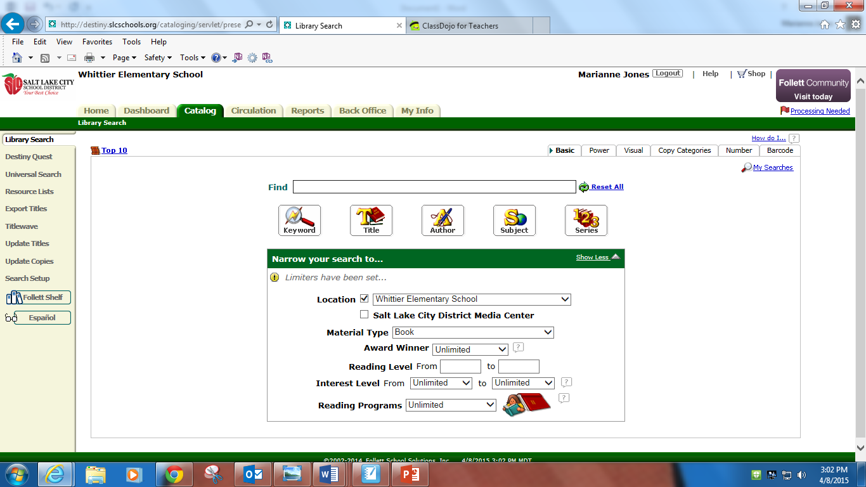

Click on “site configuration” from the left menu.
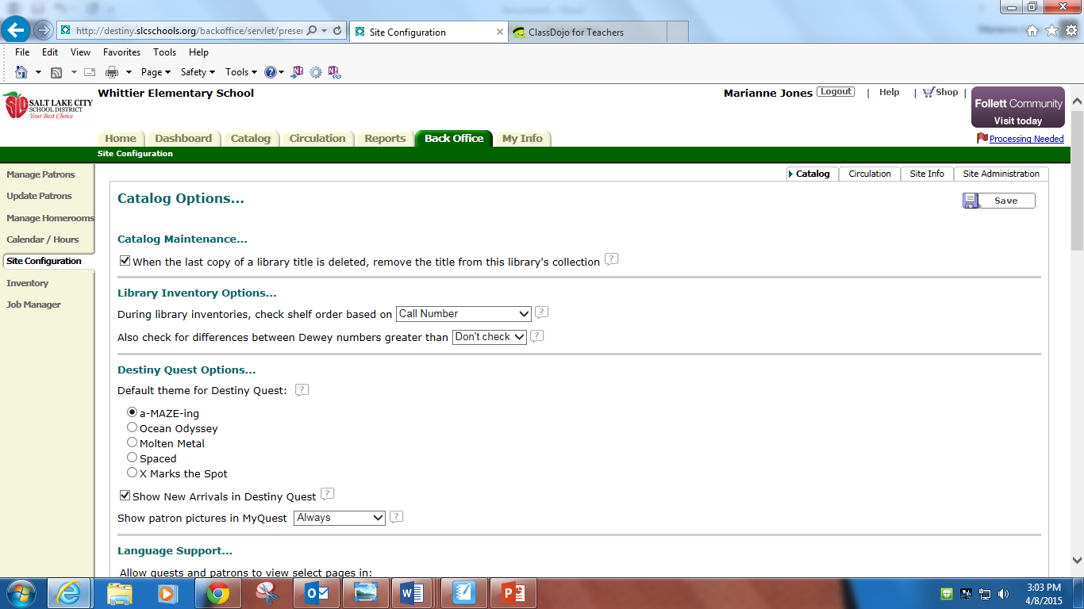
Click on the “Circulation” tab at the upper right.
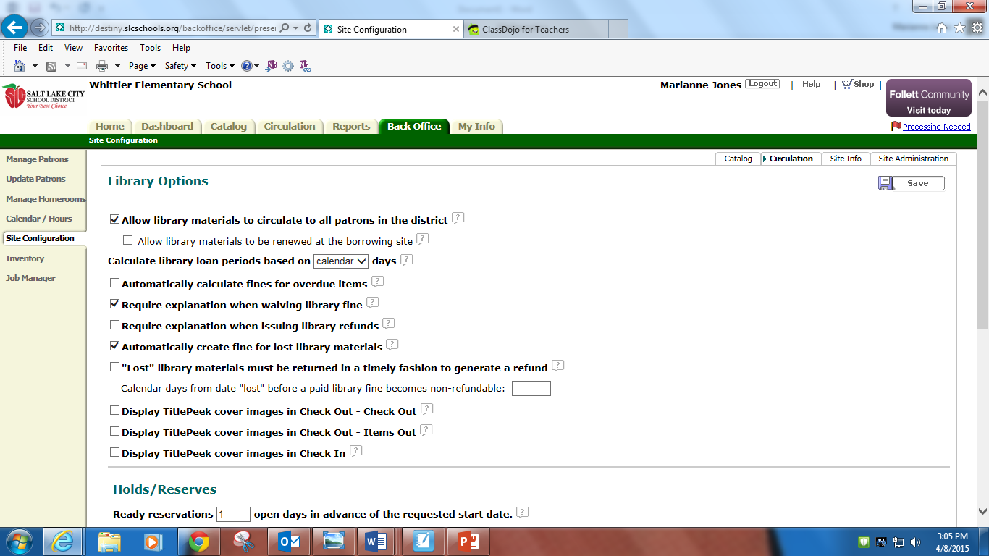

Scroll to the bottom of the page and you’ll see “Circulation Sounds”.
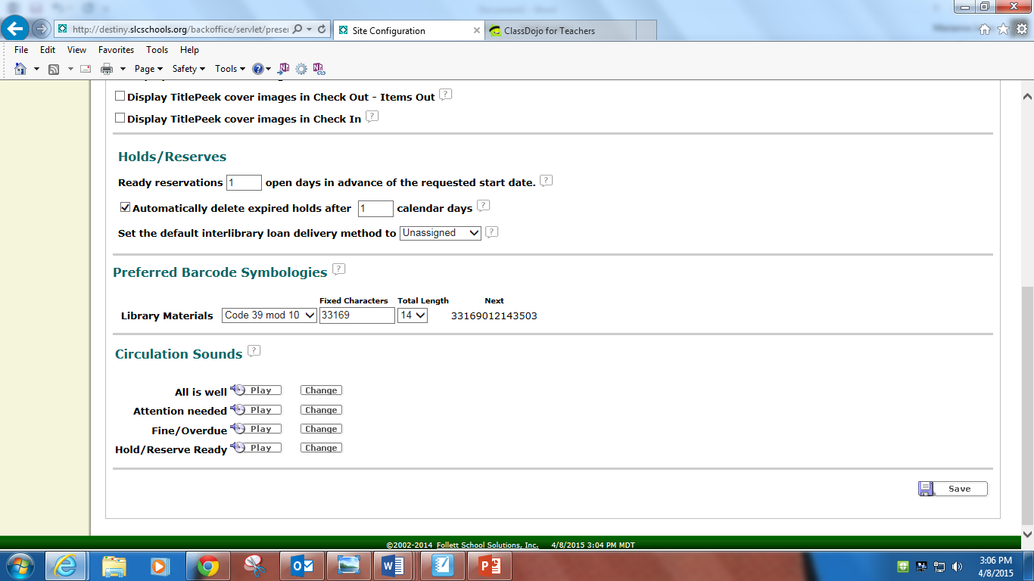

Click on “change” to change whichever sound you’d like.

Search Google for the perfect sound for you! Hint: put mp3 or mp4 in the search box so you get sounds. Download the sound to your computer then browse to find your sound and upload it to Destiny. Soundbible.com is a great site for free sounds.
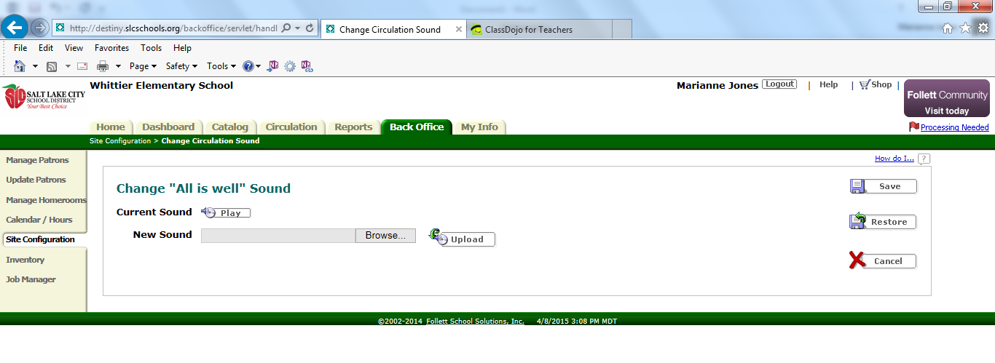

Be sure to “save” or all of your time will have been wasted. Enjoy your new customized Destiny sounds!

